Chalets and Caviar – Dyad 2. The “Why?”

Chalets and Caviar is a well-known real state agency that is particularly known for their five-star quality work. With their over 15 chalets available for sale and rent it is understandable that they ask for a "clear, uncluttered, design that exudes luxury."

Taking the client’s needs into consideration I made the decision to choose the Dyad 2 theme for their website.

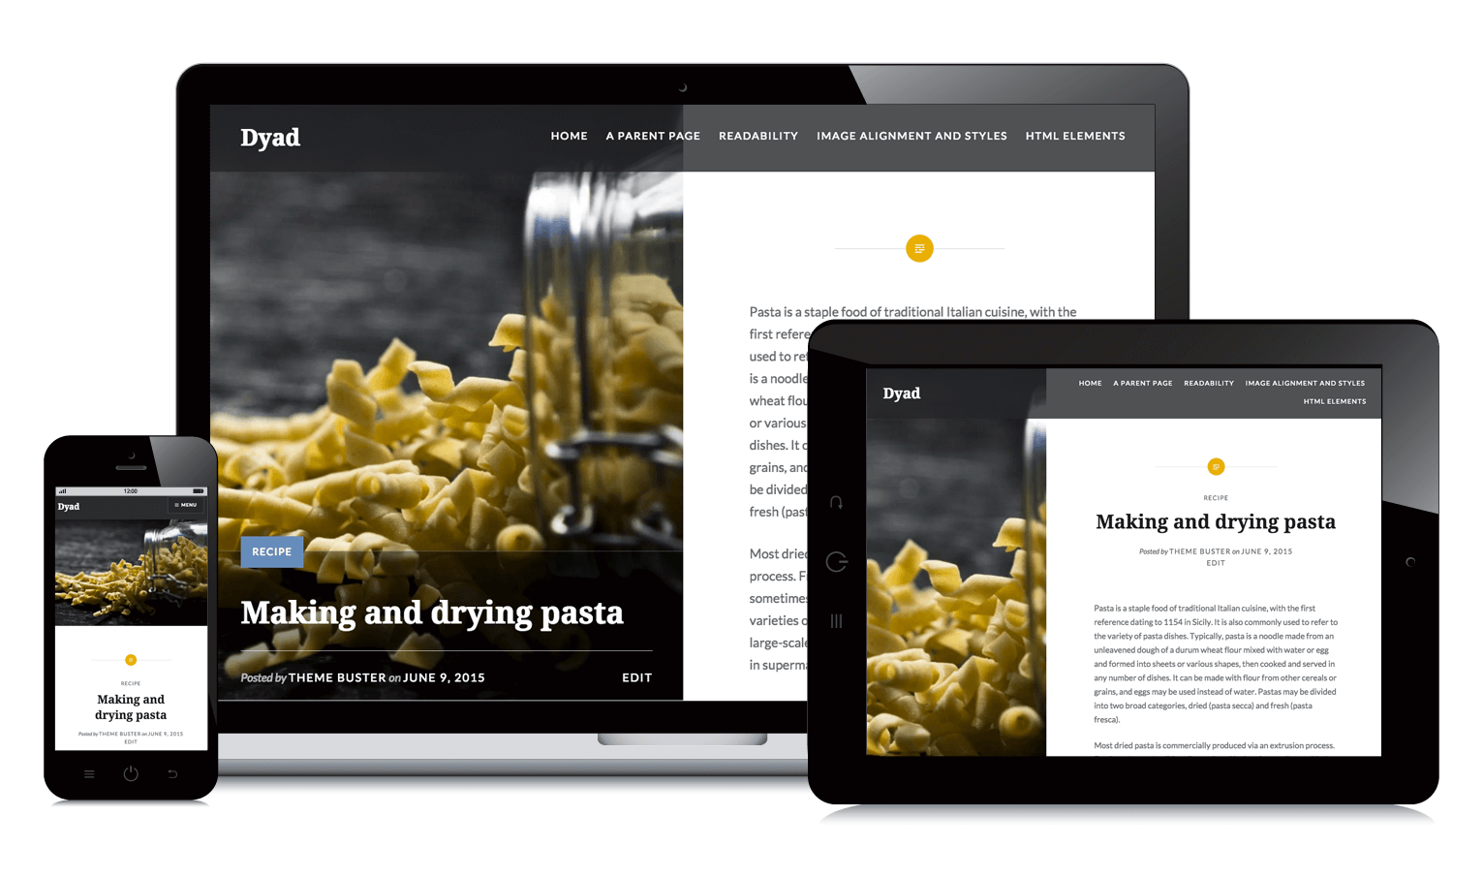

“Dyad 2 displays words and images in perfect balance”. The type of clients that require the services of Chalets and Caviar tend to be busy people that are looking for the perfect chalet, with little to no time to waste. My client makes sure their clients are quickly satisfied and it was my job to follow this pattern. The balance offered by Dyad 2 allows the users to have at their disposition the images and the beginning of the description, this way being able to reach the more emotional clients that can connect to the particular featured photo and the more rational ones that can easily relate to what is offered by the text area.

Despite this theme being originally created for what it seems to be the restaurant world, it can be easily customized to become whatever the developer wants it to be; in this case I was able to change the font and personalize the post content to make it luxurious and full of class. This is proven in the use of constellations name for the chalets. Constellations are usually related to tranquility, and this simple association allows for the theme to immediately take the direction I wanted it to go in, a direction of relaxation for the user.

In conclusion, it is evident that the chosen theme follows the needs of the client by providing them the clear and uncluttered characteristics, thanks to the very well-organized layout. On the other hand, the luxury aspect, as previously explained, is clearly displayed through the customizations that were done.